ITEM DETAILS
Name of Item | Inter-War Flats
Other Name/s  Former Name/s | 133-135 Hasting Parade, North Bondi
Item type | Built
Item group | Flat Building
Item category | Flat
Area, Group, or Collection Name | Unknown
Street number | 133-135
Street name | Hastings Parade
Suburb/town | North Bondi |  |  |  |  | Postcode |  |  | 2026
Local Government Area/s | Waverley
Property description | SP 7142  SP 13666
Location - Lat/long | Latitude | -33.889778 |  | Longitude | 151.28424
Location - AMG (if no street address) | Zone |  |  | Easting |  |  |  | Northing
Owner | Private
Current use | Residential
Former Use | Residential
Statement of significance | 133-135 Hastings Parade, Palm Court Flats, is a fine and intact example of a pair of Inter-War flat buildings in the Bungalow style in Waverley. The building is part of a group 127-129 and 133-135 Hastings Parade.  133-135 Hastings Parade. Palm Court Flats reflects the original Queenscliff subdivision of 1881 and represents the development of Inter-War flat buildings, an important phase in the history of Waverley which represents the 1920s-1930s development boom, a prominent period of economic prosperity and speculative development in Waverley associated with the changing demographics with a shift to living in flats. It also demonstrates the importance of the 1929 extension of the tram to North Bondi.
Level of Significance | National |  | State |  |  |  | Local

DESCRIPTION
Designer

Builder/ maker

Physical Description | 133-135 Hastings Parade North Bondi, Palm Court Flats are a two-storey freestanding pair of flat building that is part of a group 127-129 and 133 -135 Hastings Parade. They date from the Inter-War period - a key period of significance of the North Bondi precinct. The building displays features of the Inter-War Bungalow with Federation Arts & Crafts features - including brick finish (now rendered) contrasting with rusticated sandstone and timber shingles, projecting bays, symmetrical rectangular form, medium-pitch simple hipped roof - and is part of group in Hastings Parade.  The building is setback 3 metres from the street on a rectangular site approximately 12 metres wide that reflects the original subdivision pattern in a suburban setting that has retained much of its historic context.  The site has a fence of sandstone block approximately 0.9 metres high, which compliments the setting of the place. The site features a central path, trees, hedging, indigenous and exotic vegetation and provides an appropriate setting for the building. The building is in good condition and substantially intact.  Elements impacting upon the integrity of the site include rendered facebrick.
Physical condition  and  Archaeological potential | The building appears to be in good condition
Construction years | Start year |  | Finish year |  | Circa | c1920
Modifications and dates

HISTORY
Historical notes | 133-135 Hastings Parade, North Bondi, was part of 13 acres 1 rood 9 perches subdivided under DP 689, then resubdivided as Queenscliff Estate under DP 786 by Michael Hegarty, James Horan and William John Clarke in 1881. Lots in DP 786 were sold from 1882 (552-91). The site is Lots 45 & 46 in Section 7 of DP 786. Lots 6,7, 46 & 47 were purchased by Frederick Martin in 1882. (Transfer 56081) (574-143). In 1896, Lots 46 & 47 were transferred to John Toole of Ultimo (1223-165). In 1920, Lots 46 & 47 were sold to Lewis Augustus Bourke, commission agent. In 1924, Bourke purchased lots 48 & 49 (now 127-129 Hastings Parade). In 1928 Lots 46-49 were sold to R.W. Burt (4286-62/63). John Stewart of Balmain purchased Lots 44 & 45 of Section 7 in 1883. (669-84). In 1911, Lot 45 sold to William Chaffing of Darlinghurst (2117-159) and in 1920 was purchased by Lewis Augustus Bourke. He purchased lots 46 & 47 in 1924. Lot 45 was purchased by R.W. Burt in 1929. Burt sold Lot 45 to Alison Foster of Willoughby in March 1940. Burt also sold lot 46 in 1940 to Elizabeth Schelpp. The buildings are likely to have been built c1920 when the sites were in the ownership of Lewis Bourke. The 1930 aerial photograph shows the buildings constructed. The 1932 Sands directory notes ‘Palm Court Flats’ in the location of the site (then numbered 99-100).

THEMES
National  historical theme | 3 Developing local, regional and national economies  4 Building settlements, towns and cities  8 Developing Australia’s Cultural Life
State  historical theme | Transport  Towns, suburbs and villages  Land tenure  Accommodation  Domestic life
Local  historical theme | Traffic and Transport  Flats and Bungalows  Speculation and Subdivision

Assessment
A: Historical Significance | 133-135 Hastings Parade, North Bondi, has historic significance at a local level as it reflects the original Queenscliff subdivision of 1881.  Palm Court Flats, 133-135 Hastings Parade, has historical significance at a local level as it represents the development of Inter-War flat buildings, an important phase in the history of Waverley which represents the 1920s-1930s development boom, a prominent period of economic prosperity and speculative development in Waverley associated with the changing demographics with a shift to living in flats.  133-135 Hastings Parade, North Bondi, Palm Court Flats has historical significance at a local level as it demonstrates the importance of the 1929 extension of the tram to North Bondi.
B: Associative | To date no significant historic association has been identified.
C: Aesthetic significance | 133-135 Hastings Parade, North Bondi, Palm Court Flats has aesthetic significance at a local level as a fine and substantially intact example of a two-storey freestanding pair of Inter-War flat building in the Bungalow style that are part of a group 127-129 and 133-135 Hastings Parade.  The buildings display features of the Inter-War Bungalow with Federation Arts & Crafts features including brick finish (now rendered) contrasting with rusticated sandstone and timber shingles, projecting bays, symmetrical rectangular form, medium-pitch simple hipped roof.
D: Social significance | To date no social, cultural, and spiritual significance has been identified.
e) Technical/  Research significance | To date no research/technical significance has been identified.
f) Rarity | Research to date indicates that 133-135 Hastings Parade, Palm Court Flats are not rare.
g) Representative-ness | 133-135 Hastings Parade, Palm Court Flats, has representative significance at a local level as a fine and intact example of a pair of Inter-War flat buildings in the Bungalow style in Waverley.
Integrity | The building is substantially intact.

HERITAGE LISTINGS
Heritage listing/s | Draft Waverley LEP 2012

INFORMATION SOURCES
Type | Author/Client | Title | Year | Repository
 | Waverley Council | Waverley Heritage Policy | 2007
 | Waverley Council | Waverley Heritage Study | 1993
 | Perumal Murphy Pty Ltd | Waverley Heritage Study | 1990
 |  | Certificate of Title, Vol 1032 Fol141 |  | NSW Land Registry Services
 |  | Certificate of Title, Vol 574 Fol143 |  | NSW Land Registry Services
 |  | Certificate of Title, Vol 1223 Fol165 |  | NSW Land Registry Services
 |  | Certificate of Title, Vol 4286 Fol62/63 |  | NSW Land Registry Services
 |  | Certificate of Title, Vol 669 Fol84 |  | NSW Land Registry Services
 |  | Certificate of Title, Vol 2117 Fol159 |  | NSW Land Registry Services

RECOMMENDATIONS
Recommendations

SOURCE OF THIS INFORMATION
Name of study or report | Heritage Policy by Waverley Council reviewed by Architectural Projects 2023 |  | Year of study or report
Item number in study or report

Author of study or report
Inspected by
NSW Heritage Manual guidelines used? |  |  |  | Yes |  | No
This form completed by |  |  |  | Date

IMAGES

Image caption | 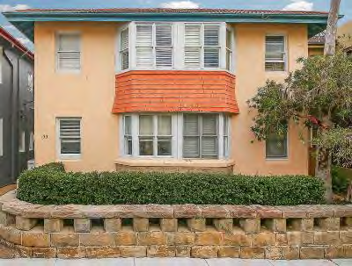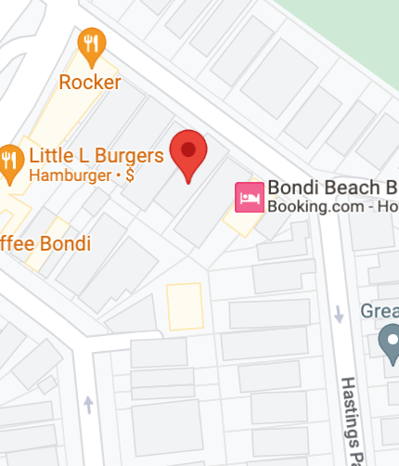  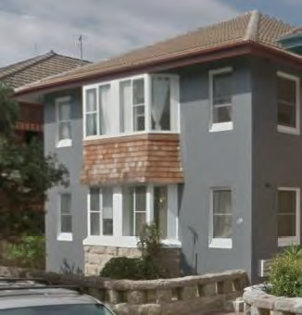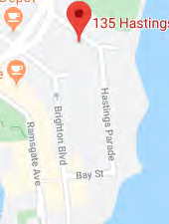
Image year |  | Image by | Google Maps | Image copyright holder

Image caption | 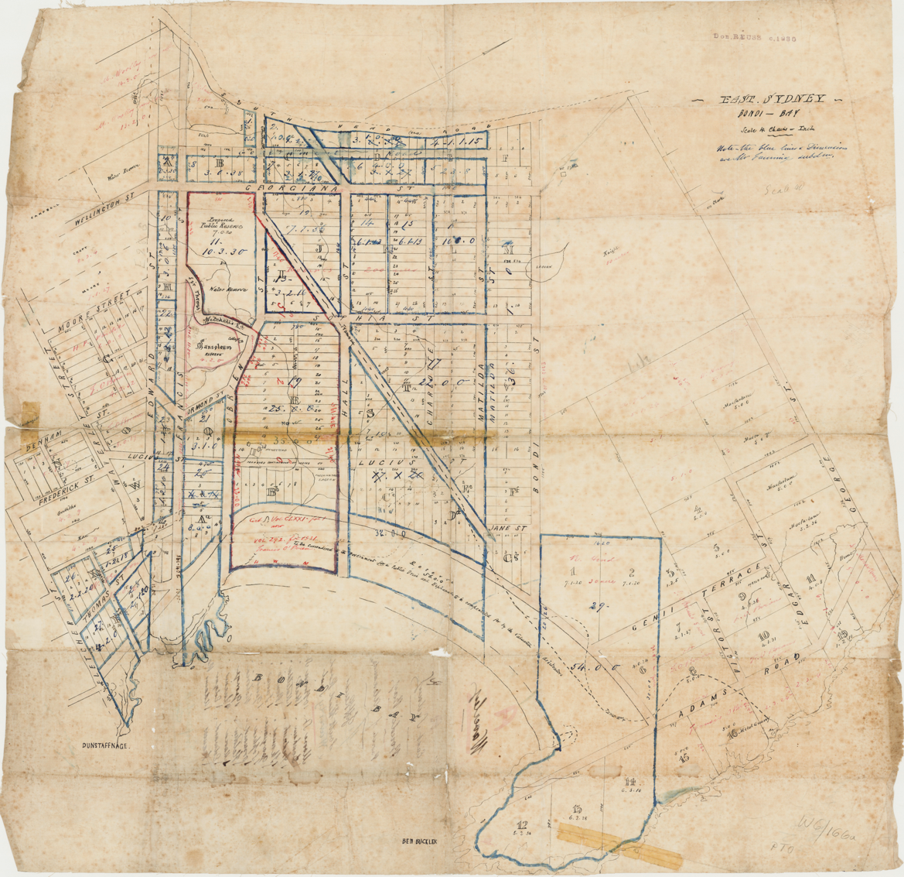
Image year | Undated | Image by | State Library of New South Wales | Image copyright holder

Image caption | 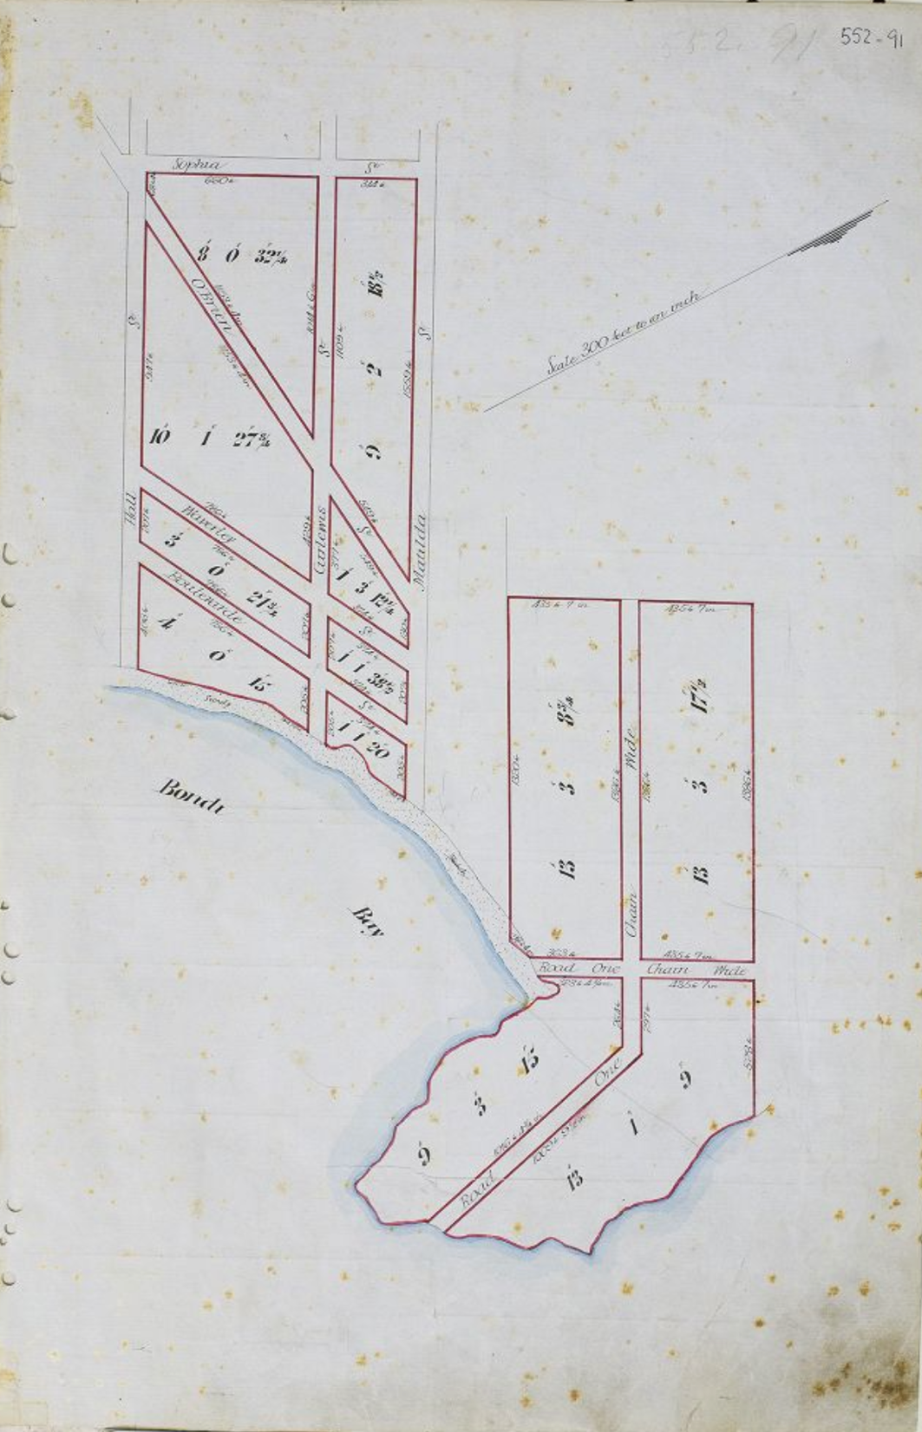
Image year | 1881 | Image by | Historical Land Records Viewer | Image copyright holder

Image caption | 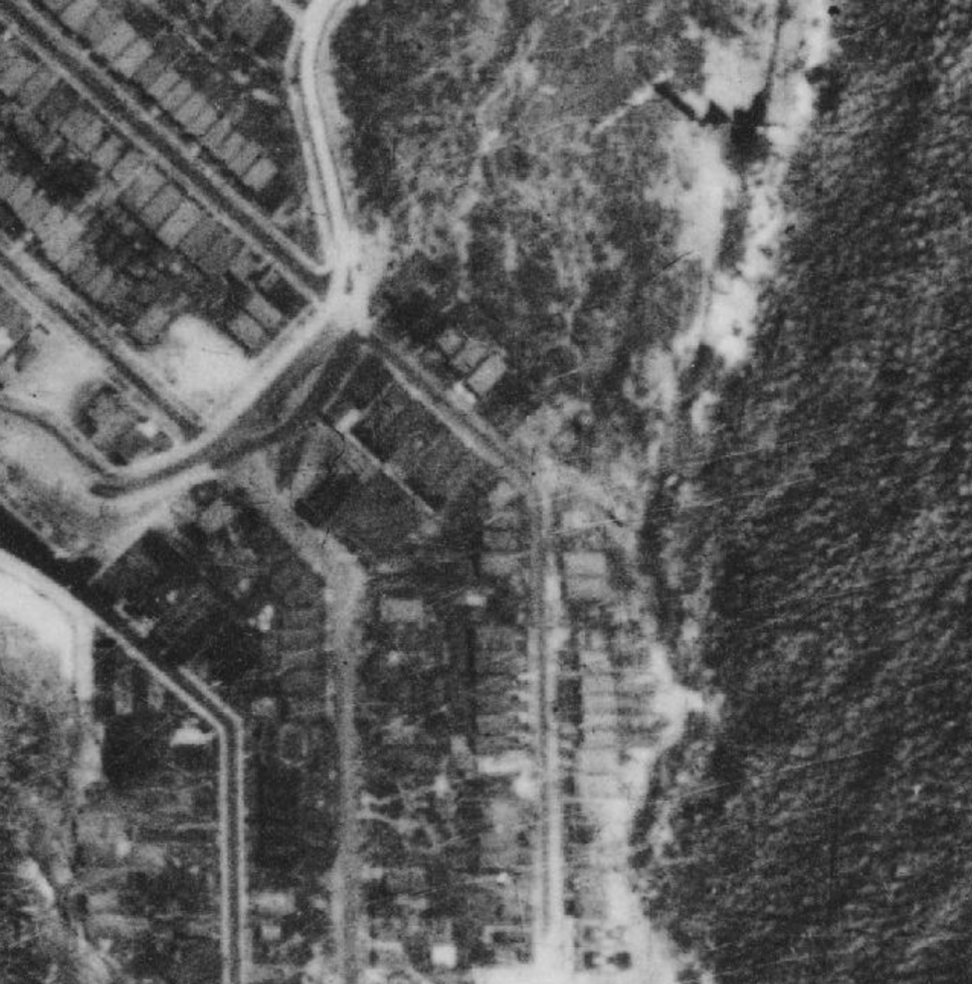
Image year | 1930 | Image by | NSW Historical Imagery | Image copyright holder

